Joseph Armas

Justin Hoang

Ciena Barraquias

Group 6 Key Hooks Phase 2

Please refer to the video for the bulk of questions for demonstration and explanation. We used the SqlAlchemy session for the “seed” data because it was more convenient and made more sense to populate the table that way.

**Youtube video link:**

<https://youtu.be/3kEn731NL8c>

Request Table:

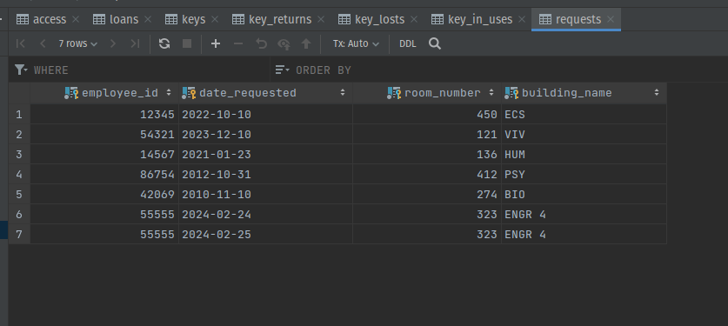

Loans Table:

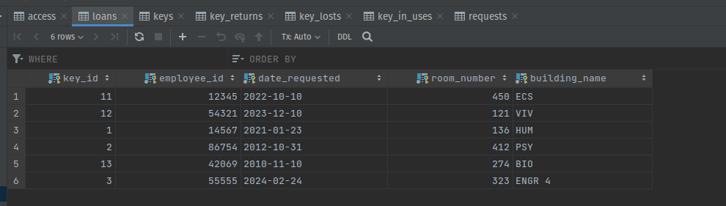

Keys In Use Table: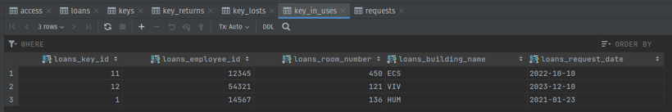

Key Returned Table: 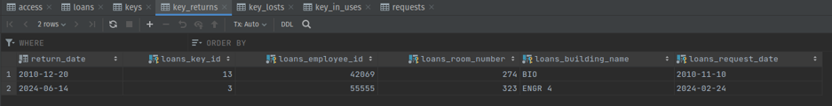

Key Lost Table: